ShortHike

Design document

Kai Backman

kai@shorthike.com

“My dream is to build a space station”

Design premise
ShortHike is a single player space station game where the player takes the role of a space station designer and manager. The basic gameplay is adding, moving, deleting and repairing individual modules in a 3D environment. The station is always a single rigid unit and the main user interface is organized around one screen. Multiple modules can be combined into assemblies that have superior performance and subsequently act as a single unit. The game sessions are based mission positioned in larger campaigns. The main story backdrop is the evolving human Type II civilization and the fate the ShortHike Foundation.
Goals and rewards
Main reward schedule
Time | Goal | Reward | Progress Visualization
30 s | Find spot for next module | Module activation sound, seeing the module in your design. | You see your module on the station and the station grows.
3 min | Complete new assembly | For every assembly completed the player gets experience points | Visual on the screen.
10 min | Unlock new module | New module available for building. | Locked modules have the number of experience stars required under them. When you have enough stars the module shows up as grey.
30 min | Complete single mission target | New assembly available for building. | Progress towards mission targets is shown in the global menu.
2 h | Complete the mission | Unlock the next mission(s) | Mission targets show up in the global menu as small icons with grey areas. Each icon shows a small progress bar underneath that gives the progress towards the completion of the mission.
2h | Complete a challenge (optional) | Different depending on the challenge completed | Challenges show in the shell screen. 5 challenges with most progress on them show up in the mission pane.
15h | Unlock new Campaign | A whole new campaign with new missions and challenges. | Builder’s Dilemma contains all available Campaigns. The mission screen also has all campaigns up for show.

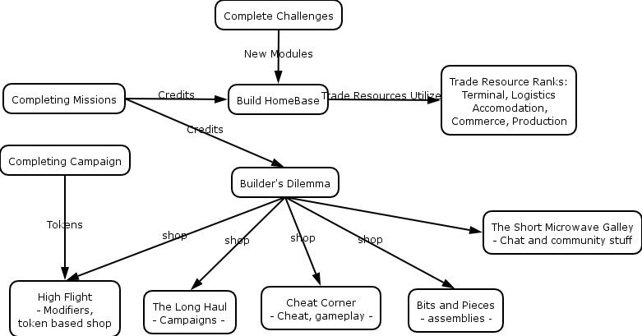

Resources
There are three types of resources in ShortHike. The fundamental aspects affect the station on a global scale, base resources are resources that are present on almost all stations while trade resources differ wildly from one station to the next.

Player tokens
These resources are player specific and stay between game sessions.
Credits | The scoring process of each mission awards the player a set of personal credits usable on their home base. These credits can then be used for purchasing new modules to their personal station or to shop at the Builders Dilemma.
Patches | For completing challenge goals. Each patch adds a new module to be used on the HomeBase.
Stars | These special tokens are received after completing Campaigns and can be used in the High Flight shop to buy original and special items.
Rank | The rank of the player is based on the total amount of experience they have collected. Rank is just a reward in itself.
HomeBase | This is a special permanent base that the player can build on. Utilizing modules of type Terminal, Logistics, Accommodation, Commerce and Production will add a permanent income bonus based on the amount of resource online.
Assemblies | The Bits and Pieces Shop in the Builder’s Dilemma sells assemblies to the player. These can be used in any game where applicable.
Cheats | Cheats are ways to bypass and make missions easier. They can be bought at the Cheat Corner shop.
Campaigns | Campaigns are also bought from BD. Published player missions are also made available through the Builder’s Dilemma.

Fundamental resource
Time
Credits | You can go into debt a maximum of 10% of the new purchase value of all modules around or $200M, whichever is higher. The interest for running up debt is 2% until 50% of max and 5% to max. Interest is counted as a standard expense and lowers your profitability. If you go over your debt max the game is over (if the script doesn’t do something different)
Flight Control | Mass and booster capability for the current maneuvering requirements. Missions can add requirements to make transfer missions for example.
Mission | Mission targets

Base resources
Name | Model | Units | Notes
Energy | Activation | kWe | Usually electric energy
Thermal Control | Activation | kWt | The principal waste of space stations
ECLSS | Diffusion | 0-10 (0 - space suit, 1 - shirt sleeve, 10 - super luxury) | ECLSS is a measure of the working comfort level in the module.
Stress | Diffusion | 0-10 (0 no external stress, 10 N.Y. Times Square) | Based on how much of flow capacity is used. Higher levels of stress generate more events.

Trade resources
Trade resources flow freely around the station. Traffic measures the total flow of resources through a specific module. There are now flow restrictions, but high levels of traffic add to stress. Traffic is measures in ton/hour. Some pure structure modules (trusses etc) have no capacity for channeling trade resources. A typical node would have a trade resource capacity in the 2-3 ton/h range

Resource | Cost | Dir | Notes
Traffic |  | Dual | This is a compound resource that is produced indirectly by all the trade resources combined. It measures the amount of traffic through a module
Passengers | 0.15 | Dual | People traveling to/from terminals
Visitors | 0.3 | Single | Visitors to the station, cleared at terminals
Crew | 0.2 | Single | Workers at the station
Service | 0.3 | Single | Services provided by commercial modules to people accommodated on the station
Cargo | 0.1 | Dual | Cargo on it’s way to somewhere, either inside the station or outside it
Commodities | 0.20 | Single | When Cargo is destined for the station it becomes a commodity

Flow diagram
This is the typical flow or trade resources within a station.
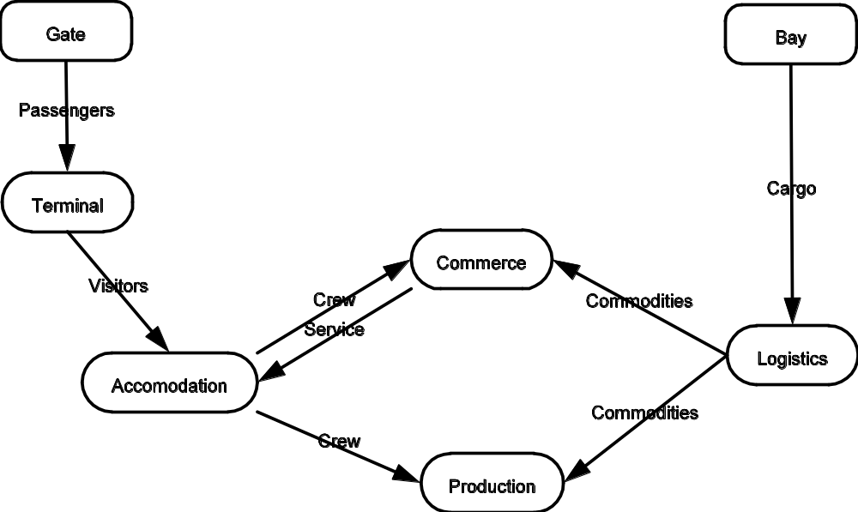

Ranks and rewards
Ranks
Name | Assembly size | Experience
Assembly Worker | 2
Assembly Lead | 3
Assistant Operator | 5
Operator | 6
Head Operator | 8
Junior Controller | 10
Controller | 12
Senior Controller | 15
Junior Engineer | 20
Engineer | 25
Senior Engineer | 35
Junior Architect | 45
Architect | 50
Senior Architect | 65
Director | 100

Game mechanics
Time is turn based with action points. Each move, add, delete or repair action uses up one action point. The amount of action points depends on each mission and generally varies between 4-20 points. The mission can adjust this as necessary. One turn is one month. Modules change trade resource outputs and produce income or expenses only on turn changes.
- Events usually have a temporal effect, accident for example raise stress.
- Gates and Docks have a bounding size that exceeds the direct physical size of the dock (to give space for the shuttle). They also define a Vector3 docking position in this free space. The docks need a direct connection to the sphere that surrounds the station from this docking point. The free clearance is tested using a frustum extending from this point radially out to the sphere.
- The cost of moving is 1.0% of module price. Recycling a module gives back 35% of value.

Assemblies
Assemblies are a way to permanently group together a lump of modules. Assemblies are pre-defined and need to be bought from the Builder’s Dilemma to be used. Each assembly defines a forming cost (usually 10% of modules needed) and provide their own separate flow and production values.
Design Issue: Should multilevel combination be allowed? How about defining what is a module? Should parts be defined as “primary” and secondary meaning that only primaries are used when checking for the assembly? How about spatial arrangement? Is that checked for?

Re-Boost operation
Re-boost capability is measured as delta-v. As a reference the ISS requires a delta-v of approximately 43m/s per year. The delta-v requires is calculated by finding the air resistance and comparing that to mass. Thrusters are then used to raise this capacity. In case of too little re-boost capacity the cost of additional re-boosts is automatically deducted. Some missions might require higher delta-v values for special missions like boosting a station to another orbit. As an example an aerobraked Mars transfer or LEO-L5 would require about 4000m/s of delta v.
The boosters need to be correctly oriented and have full clearance to provide their thrust. Clear space is defined as an angle of 20% in the rear firing direction. Air resistance is measured as the radius of the cross section circle in relation to the direction of travel.

Stress addition based on distance from centerline:
From centerline | 25% | 50% | 75%
Stress bonus | 20% | 40% | 80%

DES algorithms

Profit algorithm
Modules use a trade resource as their primary. Even if a module (say an anti-matter factory) can require high levels of energy, it still does nothing if it hasn’t a steady commodity flow running. So for the anti-matter factory even a small amount of commodities will generate huge profits.

Variables:
module_constant_primary – This is the main control on the profitability of the module
module_constant_eclss – Higher comfort levels generate better profitability.

Profit = primary_flow_resource * module_constant_primary
* (1 + bonus_stress * module_constant_stress)
* (1 + bonus_eclss * module_constant_eclss)

Flow algorithm
After a lot of research into very complex flow algorithms this flow implementation is very simple system based on reservoirs of fluid. The production flows aim to raise the reservoir levels to max while the consumption outflows lower the reservoir levels. The stability of the system is controlled by the size of the reservoirs and the sensitivity to changed levels. The system uses a discrete event model.

Base localized flow calculation
Global: quanta, priority_queue, sentitivity (range 1-5)
Node variables: current_level, max_level, max_flow capcity, level (derived)
Edge variables: flow, max_flow

max_level = max_flow * ports * 1 / sensitivity

Update sequence
1 Calculate current_level = time_elapsed * net_flow
-- time_advance update only
2 Calculate in first inflow and then outflow for each edge (positive is outflow):
flow = sensitivity * (my_level – other_level) * max_flow. Cap at max_flow.
3 Propagate changed flow values to neighbours
-- end of time_advance update only
4 time_advance = quanta / net_flow

Diffuse algorithm
Diffusion speed is based on the relative masses of different modules. Large heavy modules should take longer to be diffused than smaller lighter modules.
Diffusion calculations
Global: quanta, priority_queue, sensitivity
Node: indigenous, current, target, mass

Update sequence
1 Calculate current base on time_elapsed and target
-- time_advance update only
2 Propagate new value to neighbours
-- end of time_advance only
3 Find new target. Special case: if indigenous = 0, the result is also 0
target = indigenous * my_mass * connected_port_num + connected_a * connected_a_mass + …) / (my_mass * connected_port_num + connected_a_mass + …)
4 Find new time_advance
delta_current = (target – current) / sensitivity
time_advance = min(quanta / speed, (target – current) / speed)

Activation order
When a module tries to go online it activates each needed resource one at a time. The idea is to require higher level resource first, to make lower level providers go online first. The activation order is:
- Proper position and orientation (Gate/Bay not connected to space, thruster pointing the wrong way)
- Stress (science modules and similar who require low stress environments)
- Service
- Crew
- Commodities
- Visitors
- Passengers
- Cargo
- ECLSS
- Thermal
- Energy

Events and Hit Points
Each module has a certain number of hit points. Different events can reduce or increase this amount. Modules heal 1HP/month and the player can add an additional 10HP per action point. Once a module reaches 0 HP it is permanently damaged and can not be salvaged. Otherwise modules are essentially eternal but their capacity decreases and maintenance increases with age. At some point it might be prudent to replace them with newer versions.
Lifecycle | Production and HP capacity | Maintenance increase
0% | 100% | 0%
50% | 95% | 5%
70% | 90% | 10%
80% | 85% | 15%
90% | 80% | 20%
100% | 75% | 30%
110% | 50% | 40%
150% | 40% | 60%
200% | 35% | 80%
300% | 30% | 100%
500% | 25% | 110%
1000% | 20% | 120%
2000% | 15% | 130%

User interface
The user interface is HUD layer based. Each individual layer can be turned on or off independently and they generally do not have layout interactions.
Additional stuff in the Home Base:
- Builder’s Dilemma
- Stats page

- Layers visualize the flow of a single resource (or traffic for a total of 11).
- XSI style quick click/key press activates indefinitely, long hold releases into previous visualization mode when released.
- The flow visualization is a stick figure of the station with flow shown as animation. The size of the sticks indicate relative amount of flow.
- Resource icons have bar to indicate loading. Green OK. Yellow <20% spare capacity, red overloaded.
- Hovering over any module in the station will show a pop-up with information on that module. The information will show graphically with icons and numerically the status of the module.
- Once the pop-up functionality is activated the timer for subsequent activations is much shorter. The timer is reset to normal either by pressing ESC, or moving to a non-active area. If ESC is pressed, the pop-up will not activate until moved over a new module. Holding Space will activate the pop-up immediately.
- The Status layer is an overview of the station status. In the Status view each module will have a small icon showing the first resource on the activation list that it’s lacking. When a module reaches 70% of its lifespan it gains a yellow tint that turns into full yellow at 85% of lifespan.
- Show pop-up timer by solidifying the edges of the pop-up box once 50% of the time has elapsed.
- The camera moves smoothly from one place to another when the user changes focus.
- All UI and simulation parts can be enabled or disabled at runtime. Disabling a simulation resource will put an empty space where its icon was and all modules depending on that resource will act as they were constantly satisfied. Disabling module manipulators will simply remove them from the dock. Disabling Credits will give unlimited funds. Disabling Experience will make all modules known. Disabling Flight Control will place no limits on stations. Missions can’t be disabled. Disabling individual modules will render an empty spot for their icon.
UI widgets interaction
Resource Icon | Mouse-Over | Pop-Up with numerical information on the capacity and consumption of the resource, a graph with past consumption and production and a list of 5 largest consumers/producers.  Dependency graph showing all dependencies related to this resource.  Pop up works with Hold-Release
 | Click (key/mouse) | Select this visualization layer permanently. Do not show the dependency graph.
 | Hold-Release (key/mouse) | Temporarily show this visualization layer. Revert to last selected layer once released.
Build Icon | Mouse-Over | Pop-Up with numerical information on the performance of the module, a larger image, and the number of such modules on the station. Dependency graph showing modules providing resources needed and modules using resource from this module.
 | Click | Select this module for using in addition. Displaces the second module in the module stack and bumps down the first to second place
Non-Researched module (enough XP to research) | Mouse-Over | Same information as for a Build Icon
 | Click | Use Experience to research this module. The module is instantly available for building.
Unknown module (not enough XP to research) | Mouse-Over | Show graphically and numerically how much more Experience is required to research this module. Show a static overlaid picture of the module.
Credits Icon | Mouse-Over  Click | Pop-Up with graphical and numerical breakdown of finances. If window clicked open then a second click is required to close.
Experience Icon | Mouse-Over  Click | Pop-up with information on experience collected and the availability of the economics bonus. Show how much must be achieved for the next level of bonus.
Flight Icon | Mouse-Over  Click | Pop-up with information on the 10 heaviest groups of modules, air resistance and map of orbital position.
Mission icon | Mouse-Over  Click | Pop-up with mission description and status of goals.  Normally shows the status with a number of small icons.
Rotate icon | Click | Rotate selected module in the desired direction 1/8 of circle arc
 | Control-Click | Rotate selected module in the desired direction 1/32 of circle arc

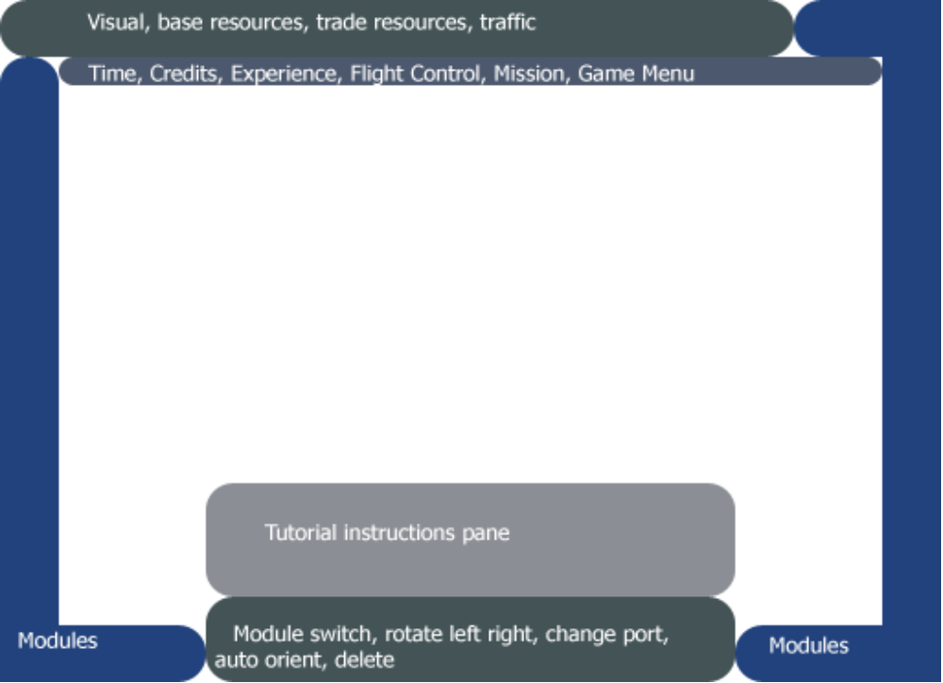

- If a module control icon isn’t available the Pop-Up informs why this is (connected, would sever station in pieces, not auto orientable).
- Auto-orienting rotates a module with directional requirements (like solar panels) to face in the most favorable direction.
- The only way to rotate or change ports is using the icons or the keys.
- Position selection is by clicking on a port. When hovering over a port the module should show with the transparent marker to indicate position.
- Collisions should be shown by opening red transparent markers for the module that has a collision. In case all rotational positions create collisions then the add/move marker should also be colored red.
- Modules supporting auto orientation should pick the best possible orientation honoring collisions.
- Credits icon shows loss with red circle. Each small red circle corresponds to -100/month. Each large to -500/month. After two large a plus is shown. A star is shown for every 1000/month profit. A big star for every 5000/month profit. After two big stars a plus is shown.
- Instructions pane. The instructions pane (for tutorials) has the ability to extend a vector pointer either at modules or icons. You can move back and forth with instructions, and the instructions move automatically once you do the action.
- Incorrect orientation (solar panel, radiator pointing the wrong way) or incorrect position (space dock not aligned properly) show up on the Status layer.
- Multiple selection lets you move part of a larger station, add it as a template (three template slots available). Ctrl-A selects all modules.

Mission editing
Missions are based on a trigger structure similar to the one used in Warcraft III. Each trigger has a set of messages it reacts on and a set of conditions to be met. Once triggered the action list determines how the trigger affects the mission. Missions can also define variables to hold bool/int/float/Module values.
- Let script enable and disable ports for greater gameplay variety. Let script enable and disable module changing to make certain modules non-accessible to the player. Give them a predetermined station to work with.
- Script should be able to retrieve and set the action of any UI button to facilitate more complex writing of missions. The only exception is the Game button controlling exit/save/load etc.
- Let script record building sequences to use in playback later on. The script can rewind to the beginning and then play the build sequence back at the player.

Missions
- Always have a primary way to solve the mission and a secondary support function. Thus if the player happens to be specialized in the wrong primary they have a larger chance of having something on the secondary.
- Timed missions to achieve something within a time limit
- Fake starting goals, the real goal is something else
- Force the station into huge debts and bail the player out at the last minute (heh)
- Free bonus modules for specific achievements: Bridge is a style module given for free after 200 modules. Upgraded to bigger bridge at 800 and 3000 modules. Costs as normal modules
- Boost mission where a station is designed to move from one place to another

Scenario: Orbit School

Name | Session 1 - Basic UI
Scenario | Orbit School
Study Objective | After the mission the player will be able to build a simple station and do basic camera movement.
Start conf. | Start out with node (disable). All resources disabled except visual. Credits enabled, experience, flight disabled. Module controls disabled. Dependencies disabled. Time disabled
Sequence | - Camera movement  - Adding new module (enable service module)  - Selecting module (first service, then enable node, disable service, and same back to service)  - Rotating module (enable rotate left, right, count down how many times to rotate)  - Move module position (enable ports to move module, count down moves)  - Change docked port (enable docked port, go next after)  - Delete module (enable delete module)  - Enable crew, node and service. Let the player build a station of 10 units. (give them plenty of credits). Hint on flow and resource requirements.

Name | Session 2 Flow: Energy, thermal, layers and dependencies
Scenario | Orbit School
Study Objective | After this session the player will be able to add the right type of modules to fix a deficiency in Energy, TC.
Start conf. | Start out with a station containing a basic infrastructure of crew, lab, LS, Service, solar panels, radiators, nodes and stuff. Deficiency in Energy and TC. Disable building, flight, XP. Time disabled.
Sequence | - Show intro to tutorial and let the player zoom around the station.  - Enable energy icon and have the user click on it (no build icons are available so dependencies don’t show up)  - Enable Thermal control icon and have user click on that one.  - Add module icons for all modules used. Non-enabled. Show dependency when hovering over a module. Have the user hover over a module.  - Show the dependency graph for energy and let the user float over energy to see it themselves.  - Add ECLSS, talk about diffusion.  - Add Stress, hint on experience.  - Enable solar panels and radiators, let the user fix up the station

Name
Scenario | Orbit School
Study Objective
Start conf.
Sequence

Name
Scenario | Orbit School
Study Objective
Start conf.
Sequence

Tutorial 3 Trade goods and making money
Start out with the basics enabled, experience and flight control and maneuvering disabled. The station is using several service modules to generate power crew and thermal for a few lab modules. One locked LS/communal and docking port module available.
- Enable Crew resource. Let player click on it.
- Enable Commodities resource. Let player click on it.
- Let the player add a few Lab modules
- Show credits, enable time (making slight profit)
- Let the player add a crew module.
- Activate services to show link between Communal and crew
- Make the player add more crew, solar panel and thermal modules to replace the service modules. Profits should go up!
- Activate visitors and commodities.
- Activate LS/communal, docking port, and have the player aim for a profit of $100/month

Tutorial 4 Larger station complexes: Experience, Flight Control
Start with a larger station without re-boost capability, and a lot of stress. One golden star and a multiplier on exp generation (exp accumulates real quick). A transfer station with only minimal crew to run a large logistics and passenger terminal complex.
- Show how stress generates experience and how it gives economic bonuses.
- Show how experience can be used to buy new modules
- Enable boosters only, show how boosters must be placed and talk about flight control
- Let the player place enough boosters to keep the station in orbit.
- Show cargo and passengers, show the player how they flow from gates and bays.
- Deficiency in bays and gates, let the player place a few.
- Give a transport capacity the player must reach.

Scenario: ShortHike Dawn
Name | That little place in Italy
Scenario | ShortHike Dawn
Description | Build a space hotel to accommodate people. Target: Crew of
Start conf.
Sequence

Name
Scenario | ShortHike Dawn
Description
Start conf.
Sequence

Mission ideas:
- Energy supply mission
- Scientific outpost
- Replace failing nuclear power system with renewable
- Build transport hub for passengers
- Build orbital luxury resort
- Build transport hub for cargo
- Build small combined transport hub

Completion status
Name | Status | Description
Building
Assemblies
Mission scripting
Experience
Challenge scripting
Flight Control
Energy
Thermal
Life Support
Stress
Traffic
Trade resources
Lifetime
Activation
New module UI

Design decisions
- Modules last forever. Updating modules that break is interesting when there is very few of them (like power plants in SimCity). Updating the bulk of them is lousy work (like Civ III units)

Technical notes
- Chunk based binary saving for all data
- Integrated asset editors for all game assets that are not defined in C++.

